文件编号：LTE-HeNB_X2AP_Load Mangement_DYCS_V0.5

TD-LTE HeNB协议栈软件系统

X2AP负载管理模块
理解报告

拟制：于萌
时间：2011.11.03

中国科学院计算技术研究所
无线通信技术研究中心
软件组
LTE协议栈研发项目组
修改记录
文件编号 | 版本号 | 拟制人/  修改人 | 拟制/修改日期 | 更改理由 | 主要更改内容  （写要点即可）
 | 0.5 | 于萌 | 2011-11-03 | 建立
注1：每次更改归档文件（指归档到组内及研究室的文件）时，需填写此表。
注2：文件第一次归档时，“更改理由”、“主要更改内容”栏写“无”。
修改列表：


本文档的程序或内容受版权法的保护，未经中科院计算所的书面许可，不得擅自泄漏、拷贝或复制本文档资料的全部或部分。
目录
1 引言 1
1.1 编写目的 1
1.2 定义 1
1.3 参考资料 1
2. X2 interface 2
2.1 E-UTRAN architecture 2
2.2 E-UTRAN Identifiers on X2 interface 2
2.3 Functions of the X2 interface 3
2.4 X2 Interface protocol structure 3
3 X2 application protocol 4
3.1X2AP services 4
3.2 X2AP functions and procedures 4
3.2 X2AP functions and procedures 5
3.2.1 Load Indication 5
3.2.2 Resource Status Reporting Initiation 8
3.2.3 Cell Activation 15

图表目录
Figure 1 E-UTRAN overall architecture 2
Figure 2 X2 Interface protocol structure 3
Figure 3 Load Indication, successful operation 6
Figure 4 Resource Status Reporting Initiation, successful operation 9
Figure 5 Resource Status Reporting Initiation, unsuccessful operation 12
Figure 6 Cell Activation, successful operation 15
Figure 7 Cell Activation, unsuccessful operation 16

Table 1 Mapping between X2AP functions and X2AP EPs 4
Table 2 Class 1 Elementary Procedures 5
Table 3 Class 2 Elementary Procedures 5
Table 4 Load Information 6
Table 5 UL Interference Overload Indication 7
Table 6 UL High Interference Indication 7
Table 7 Relative Narrowband Tx Power (RNTP) 8
Table 8 RESOURCE STATUS REQUEST 9
Table 9 RESOURCE STATUS UPDATE 11
Table 10 RESOURCE STATUS RESPONSE 12
Table 11 RESOURCE STATUS FAILURE 13
Table 12 Cause (RNL) 14
Table 13 CELL ACTIVATION REQUEST 15
Table 14 ECGI 15
Table 15 CELL ACTIVATION RESPONSE 16
Table 16 CELL ACTIVATION FAILURE 17

X2AP负载管理模块理解报告

1 引言

1.1 编写目的
本文档将作为X2接口负载管理模块的设计依据，详细说明了本模块的功能和信令流程。本说明书的读者为LTE HeNB端MAC接收模块设计、编码人员、测试人员、项目组负责人员、实验室主任及相关项目管理人员。
编写本说明书的目的在于
- 为开发人员提供依据。
- 为修改和维护本系统提供条件。
- 项目负责人将根据本文档计划和控制系统设计、开发的全过程。

1.2 定义
eNB | E-UTRAN NodeB
EP | Elementary Procedure
EPC | Evolved Packet Core
E-RAB | E-UTRAN Radio Access Bearer
E-UTRAN | Evolved UTRAN
MME | Mobility Management Entity
PLMN | Public Land Mobile Network

1.3 参考资料
[1] 3GPP TS 36.401: "Evolved Universal Terrestrial Radio Access Network (E-UTRAN); Architecture Description".
[2] 3GPP TS 36.420: "Evolved Universal Terrestrial Radio Access Network (E-UTRAN); X2 general aspects and principles ".
[3] 3GPP TS 36.423: "Evolved Universal Terrestrial Radio Access Network (E-UTRAN); X2 application protocol ".

2. X2 interface

2.1 E-UTRAN architecture
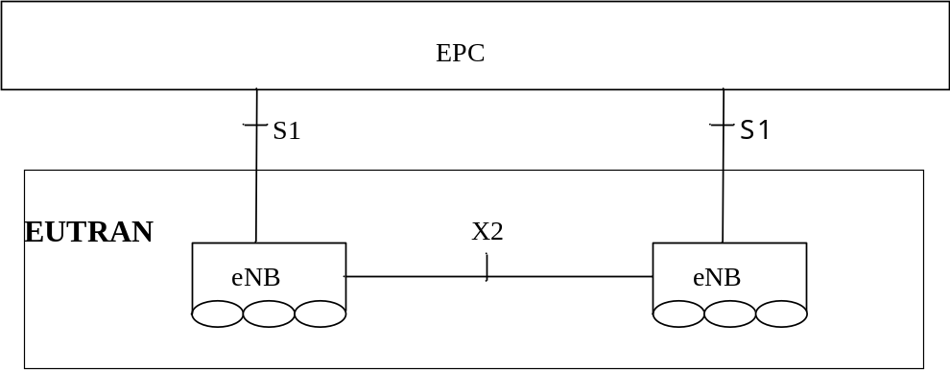
Figure 1 E-UTRAN overall architecture
The E-UTRAN consists of set of eNBs connected to the EPC through the S1.
eNBs can be interconnected through the X2.
S1 and X2 are logical interfaces.

2.2 E-UTRAN Identifiers on X2 interface
An Application Protocol Identity (AP ID) is allocated when a new UE-associated logical connection is created in either an eNB or an MME. An AP ID shall uniquely identify a logical connection associated to a UE over the S1 interface or X2 interface within a node (eNB or MME).
(1) Old eNB UE X2AP ID:
An Old eNB UE X2AP ID shall be allocated so as to uniquely identify the UE over the X2 interface within a source eNB. When a target eNB receives an Old eNB UE X2AP ID it shall store it for the duration of the UE-associated logical X2-connection for this UE. Once known to a target eNB this IE is included in all UE associated X2-AP signalling. The Old eNB UE X2AP ID shall be unique within the eNB logical node.
(2) New eNB UE X2AP ID:
An New eNB UE X2AP ID shall be allocated so as to uniquely identify the UE over the X2 interface within a target eNB. When a source eNB receives a New eNB UE X2AP ID it shall store it for the duration of the UE-associated logical X2-connection for this UE. Once known to source eNB this IE is included in all UE associated X2-AP signalling. The New eNB UE X2AP ID shall be unique within the eNB logical node.
(3) eNB1 Measurement ID:
An eNB1 Measurement ID shall be allocated so as to uniquely identify the measurement configuration over the X2 interface within the eNB that requests the measurement. The eNB1 Measurement ID shall be unique within the eNB logical node.
(4) eNB2 Measurement ID:
An eNB2 Measurement ID shall be allocated so as to uniquely identify the measurement configuration over the X2 interface within the eNB that performs the measurement. The eNB2 Measurement ID shall be unique within the eNB logical node.

2.3 Functions of the X2 interface
The list of functions on the X2 interface is the following:
-Intra LTE-Access-System Mobility Support for ECM-CONNECTED UE:
-Context transfer from source eNB to target eNB;
-Control of user plane transport bearers between source eNB and target eNB;
-Handover cancellation;
-UE context release in source eNB.
-Load Management
-Inter-cell Interference Coordination
-Uplink Interference Load Management;
-General X2 management and error handling functions:
-Error indication;
-Reset.
-Application level data exchange between eNBs
-Trace functions

2.4 X2 Interface protocol structure
The X2 interface protocol architecture consists of two functional layers:
-Radio Network Layer, defines the procedures related to the interaction between eNBs. The radio network layer consists of a Radio Network Control Plane and a Radio Network User Plane.
-The transport network layer provides services for user plane and signaling transport.
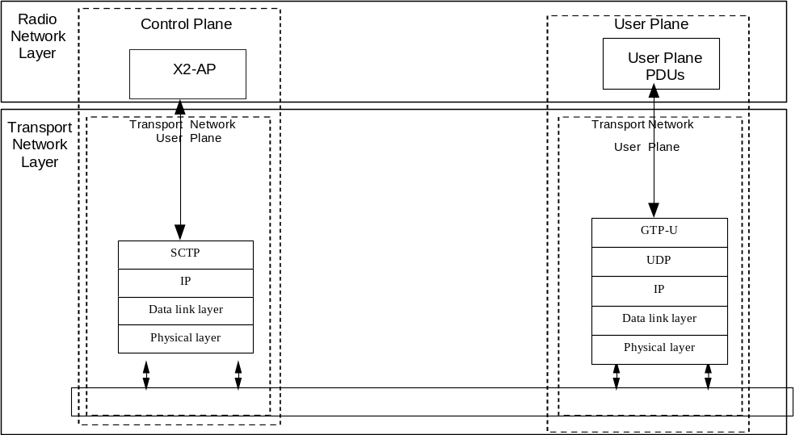
Figure 2 X2 Interface protocol structure

3 X2 application protocol

3.1X2AP services
The services an eNB offers to its neighbours.
The X2 interface X2AP procedures are divided into two modules as follows:
1. X2AP Basic Mobility Procedures;
2. X2AP Global Procedures;
The X2AP Basic Mobility Procedures module contains procedures used to handle the UE mobility within E-UTRAN.
The Global Procedures module contains procedures that are not related to a specific UE. The procedures in this module are in contrast to the above module involving two peer eNBs.

3.2 X2AP functions and procedures
The mapping between the above functions and X2 EPs is shown in the table below.
Table 1 Mapping between X2AP functions and X2AP EPs
Function | Elementary Procedure(s)
Mobility Management | a) Handover Preparation  b) SN Status Transfer  c) UE Context Release  d) Handover Cancel
Load Management | a) Load Indication  b) Resource Status Reporting Initiation  c) Resource Status Reporting
Reporting of General Error Situations | Error Indication
Resetting the X2 | Reset
Setting up the X2 | X2 Setup
eNB Configuration Update | a) eNB Configuration Update  b) Cell Activation
Mobility Parameters Management | Mobility Settings Change
Mobility Robustness Optimisation | a) Radio Link Failure Indication  b) Handover Report
Energy Saving | a) eNB Configuration Update  b) Cell Activation
In the following tables, all EPs are divided into Class 1 and Class 2 EPs.
- Class 1: Elementary Procedures with response (success or failure),
- Class 2: Elementary Procedures without response.
Table 2 Class 1 Elementary Procedures
Elementary Procedure | Initiating Message | Successful Outcome | Unsuccessful Outcome
Elementary Procedure | Initiating Message | Response message | Response message
Handover Preparation | HANDOVER REQUEST | HANDOVER REQUEST ACKNOWLEDGE | HANDOVER PREPARATION FAILURE
Reset | RESET REQUEST | RESET RESPONSE
X2 Setup | X2 SETUP REQUEST | X2 SETUP RESPONSE | X2 SETUP FAILURE
eNB Configuration Update | ENB CONFIGURATION UPDATE | ENB CONFIGURATION UPDATE ACKNOWLEDGE | ENB CONFIGURATION UPDATE FAILURE
Resource Status Reporting Initiation | RESOURCE STATUS REQUEST | RESOURCE STATUS RESPONSE | RESOURCE STATUS FAILURE
Mobility Settings Change | MOBILITY CHANGE REQUEST | MOBILITY CHANGE ACKNOWLEDGE | MOBILITY CHANGE FAILURE
Cell Activation | CELL ACTIVATION REQUEST | CELL ACTIVATION RESPONSE | CELL ACTIVATION FAILURE

Table 3 Class 2 Elementary Procedures
Elementary Procedure | Initiating Message
Load Indication | LOAD INFORMATION
Handover Cancel | HANDOVER CANCEL
SN Status Transfer | SN STATUS TRANSFER
UE Context Release | UE CONTEXT RELEASE
Resource Status Reporting | RESOURCE STATUS UPDATE
Error Indication | ERROR INDICATION
Radio Link Failure Indication | RLF INDICATION
Handover Report | HANDOVER REPORT

3.2 X2AP functions and procedures

3.2.1 Load Indication
The purpose of the Load Indication procedure is to transfer load and interference co-ordination information between eNBs controlling intra-frequency neighboring cells.
负载管理过程的目的是在eNBs控制的同频相邻小区之间传递负载和干扰协调信息。
The procedure uses non UE-associated signalling.
是与UE无关的信令。
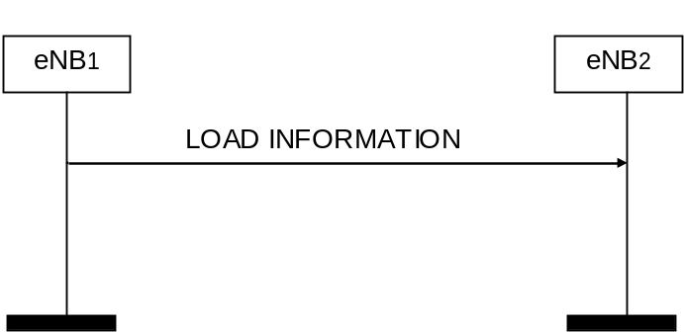
Figure 3 Load Indication, successful operation
An eNB initiates the procedure by sending LOAD INFORMATION message to eNBs controlling intra-frequency neighbouring cells.
一个eNB通过给它控制的同频相邻小区发送LOAD INFORMATION消息来发起这个过程。
Table 4 Load Information
IE/Group Name | Presence | Range | IE type and reference | Semantics description
Message Type | M |  | 9.2.13
Cell Information | M
>Cell Information Item |  | 1 to maxCellineNB
>>Cell ID | M |  | ECGI  9.2.14 | Id of the source cell
>>UL Interference Overload Indication | O |  | 9.2.17
>>UL High Interference Information |  | 0 to maxCellineNB
>>>Target Cell ID | M |  | ECGI  9.2.14 | Id of the cell for which the HII is meant
>>>UL High Interference Indication | M |  | 9.2.18
>>Relative Narrowband Tx Power (RNTP) | O |  | 9.2.19
If the UL Interference Overload Indication IE is received in the LOAD INFORMATION message, it indicates the interference level experienced by the indicated cell on all resource blocks, per PRB. The receiving eNB may take such information into account when setting its scheduling policy and shall consider the received UL Interference Overload Indication IE value valid until reception of a new LOAD INFORMATION message carrying an update of the same IE.
UL Interference Overload Indication(上行干扰过载指示): 指示相应小区每个PRB上的干扰级别；接收eNB制定调度策略时应将该信息考虑在内，并在收到新的LOAD INFORMATION消息有相同的IE进行更新之前，视其有效。
Table 5 UL Interference Overload Indication
UL Interference Overload Indication List | 1 to <maxnoofPRBs>
>UL Interference Overload Indication |  | ENUMERATED (high interference,  medium interference,  low interference, …) | Each PRB is identified by its position in the list: the first element in the list corresponds to PRB 0, the second to PRB 1, etc.
If the UL High Interference Indication IE is received in the LOAD INFORMATION message, it indicates, per PRB, the occurrence of high interference sensitivity, as seen from the sending eNB. The receiving eNB should try to avoid scheduling cell edge UEs in its cells for the concerned PRBs. The Target Cell ID IE received within the UL High Interference Information IE group in the LOAD INFORMATION message indicates the cell for which the corresponding UL High Interference Indication is meant. The receiving eNB shall consider the value of the UL High Interference Information IE group valid until reception of a new LOAD INFORMATION message carrying an update.
UL High Interference Indication(上行高干扰指示): 指示在发送端eNB看来，每个出现高干扰敏感度的PRB；接收端eNB在它的小区内应该尝试避免把小区边缘UE调度到这些相关的PRB上。
(干扰eNodeB的调度器尽量避免将高干扰敏感度频带分配给小区边缘用户，从而实现小区间干扰协调)
Target Cell ID: 指示与UL High Interference Indication一致的小区。(干扰小区)
接收eNB应该将这些信息考虑在内，并在下次更新之前视其有效。
Table 6 UL High Interference Indication
HII | BIT STRING (1..110, …) | Each position in the bitmap represents a PRB (first bit=PRB 0 and so on), for which value ‘"1" indicates ‘high interference sensitivity’ and value "0" indicates ’low interference sensitivity’.  The maximum number of Physical Resource Blocks is 110
If the Relative Narrowband Tx Power (RNTP) IE is received in the LOAD INFORMATION message, it indicates, per PRB, whether downlink transmission power is lower than the value indicated by the RNTP Threshold IE. The receiving eNB may take such information into account when setting its scheduling policy and shall consider the received Relative Narrowband Tx Power (RNTP) IE value valid until reception of a new LOAD INFORMATION message carrying an update.
Relative Narrowband Tx Power (RNTP)(相关窄带发射功率): 在每个PRB上，指示下行发送功率是否比RNTP Threshold指示的值低。接收eNB应该将这些信息考虑在内，并在下次更新之前视其有效。
（定义了特定PRBs上的RNTP门限值，通过这个门限值对PRBs的发射功率进行限制）
Table 7 Relative Narrowband Tx Power (RNTP)
IE/Group Name | Presence | IE type and reference | Semantics description
RNTP Per PRB | M | BIT STRING (6..110, …) | Each position in the bitmap represents a n_{PRB} value (i.e. first bit=PRB 0 and so on), for which the bit value represents RNTP (n_{PRB}), defined in TS 36.213 [11].  Value 0 indicates "Tx not exceeding RNTP threshold".  Value 1 indicates "no promise on the Tx power is given"
RNTP Threshold | M | ENUMERATED (-∞, -11, -10, -9, -8, -7, -6, -5, -4, -3, -2, -1, 0, 1, 2, 3, …) | RNTP_{threshold} is defined in TS 36.213 [11]
Number Of Cell-specific Antenna Ports | M | ENUMERATED (1, 2, 4, …) | P (number of antenna ports for cell-specific reference signals) defined in TS 36.211 [10]
P_B | M | INTEGER (0..3, …) | P_{B} is defined in TS 36.213 [11]
PDCCH Interference Impact | M | INTEGER (0..4, …) | Measured by Predicted Number Of Occupied PDCCH OFDM Symbols (see TS 36.211 [10]).  Value 0 means "no prediction is available"

3.2.2 Resource Status Reporting Initiation
This procedure is used by an eNB to request the reporting of load measurements to another eNB.
一个eNB通过该过程向另一个eNB请求负载测量报告。
The procedure uses non UE-associated signalling.
是与UE无关的信令。
Successful Operation
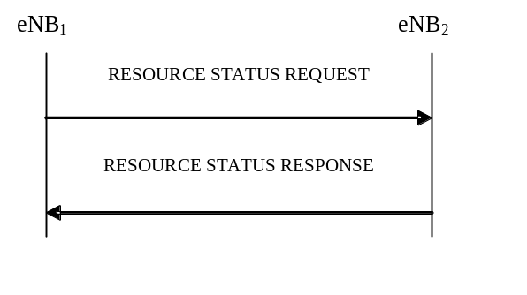
Figure 4 Resource Status Reporting Initiation, successful operation
The procedure is initiated with a RESOURCE STATUS REQUEST message sent from eNB₁ to eNB₂. Upon receipt, eNB₂ shall initiate the requested measurement according to the parameters given in the request in case the Registration Request IE set to "start" and shall stop all cells measurements and terminate the reporting in case the Registration Request IE is set to “stop".
该过程由eNB1向eNB2发送RESOURCE STATUS REQUEST消息发起。一旦收到，如果Registration Requeste为“start”eNB2应该开始请求的测量；如果为“stop”，则停止所有小区的测量，并终止报告。
Table 8 RESOURCE STATUS REQUEST
IE/Group Name | Presence | IE type and reference | Semantics description | Criticality | Assigned Criticality
Message Type | M | 9.2.13 |  | YES | reject
eNB1 Measurement ID | M | INTEGER (1..4095,...) | Allocated by eNB₁ | YES | reject
eNB2 Measurement ID | C-ifRegistration  RequestStop | INTEGER (1..4095,...) | Allocated by eNB₂ | YES | ignore
Registration Request | M | ENUMERATED(start, stop,  …) | A value set to “stop”, indicates a request to stop all cells measurements. | YES | reject
Report Characteristics | O | BITSTRING  (SIZE(32)) | Each position in the bitmap indicates measurement object the eNB₂ is requested to report.  First Bit = PRB Periodic,  Second Bit= TNL load Ind Periodic,  Third Bit = HW Load Ind Periodic,  Fourth Bit = Composite Available Capacity Periodic.  Bits 5 to 32 shall be ignored by the eNB₂ | YES | reject
Cell To Report |  |  | Cell ID list for which measurement is needed | YES | ignore
>Cell To Report Item |  |  |  | EACH | ignore
>>Cell ID | M | ECGI  9.2.14
Reporting Periodicity | O | ENUMERATED(1000ms, 2000ms, 5000ms,10000ms, …) |  | YES | ignore
If the Registration Request IE is set to "start" then the Report Characteristics IE shall be included in RESOURCE STATUS REQUEST message.
如果Registration Requeste为“start”，那么Report Characteristics应该被包含在RESOURCE STATUS REQUEST消息中。
The Report Characteristics IE indicates the type of measurements eNB2 shall perform.
Registration Requeste指示了eNB2应该执行的测量类型。
For each request cell, the eNB2 shall include in the RESOURCE STATUS UPDATE message;
对每个请求的小区，eNB2应该在RESOURCE STATUS UPDATE消息中包含如下IE：
-the Radio Resource Status IE, if the first bit, “PRB Periodic” of the Report Characteristics IE included in the RESOURCE STATUS REQUEST message is set to 1,
-Report Characteristics的第一位，“PRB Periodic”被置为1，则应包含Radio Resource Status IE；
-the S1 TNL Load Indicator IE, if the second bit, “TNL Load Ind Periodic” of the Report Characteristics IE included in the RESOURCE STATUS REQUEST message is set to 1,
-Report Characteristics的第二位，“TNL Load Ind Periodic”被置为1，则应包含S1 TNL Load Indicator IE；
-the Hardware Load Indicator IE, if the third bit, “HW Load Ind Periodic” of the Report Characteristics IE included in the RESOURCE STATUS REQUEST message is set to 1,
-Report Characteristics的第三位，“HW Load Ind Periodic”被置为1，则应包含Hardware Load Indicator IE；
-the Composite Available Capacity Group IE, if the fourth bit, “Composite Available Capacity Periodic” of the Report Characteristics IE included in the RESOURCE STATUS REQUEST message is set to 1.
If Cell Capacity Class Value IE is included within the Composite Available Capacity Group IE, this IE is used to assign weights to the available capacity indicated in the Capacity Value IE.
-Report Characteristics的第四位，“Composite Available Capacity Periodic”被置为1，则应包含Composite Available Capacity Group IE(如果里面包含Cell Capacity Class Value IE，则这个IE用来为其指示的有效功率分配权重)；
Table 9 RESOURCE STATUS UPDATE
IE/Group Name | Presence | Range | IE type and reference | Semantics description | Criticality | Assigned Criticality
Message Type | M |  | 9.2.13 |  | YES | ignore
eNB1 Measurement ID | M |  | INTEGER (1..4095,...) |  | YES | reject
eNB2 Measurement ID | M |  | INTEGER (1..4095,...) |  | YES | reject
Cell Measurement Result |  | 1 |  |  | YES | ignore
>Cell Measurement Result Item |  | 1 to maxCellineNB |  |  | EACH | ignore
>>Cell ID | M |  | ECGI  9.2.14
>>Hardware Load Indicator | O |  | 9.2.34
>>S1 TNL Load Indicator | O |  | 9.2.35
>>Radio Resource Status | O |  | 9.2.37
>>Composite Available Capacity Group | O |  | 9.2.44 |  | YES | ignore
If the Reporting Periodicity IE is included in the RESOURCE STATUS REQUEST message, eNB2 shall use its value as the time interval between two subsequent measurement reports.
如果消息包含Reporting Periodicity IE，则eNB2应该使用该值作为两次测量报告的时间间隔。
If eNB2 is capable to provide resource status information, it shall initiate the measurements as requested by eNB1, and respond with the RESOURCE STATUS RESPONSE message.
如果eNB2能提供resource status information，那么它应该启动eNB1请求的测量，并回复RESOURCE STATUS RESPONSE消息。
Table 10 RESOURCE STATUS RESPONSE
IE/Group Name | Presence | Range | IE type and reference | Semantics description | Criticality | Assigned Criticality
Message Type | M |  | 9.2.13 |  | YES | reject
eNB1 Measurement ID | M |  | INTEGER (1..4095,...) |  | YES | reject
eNB2 Measurement ID | M |  | INTEGER (1..4095,...) |  | YES | reject
Criticality Diagnostics | O |  | 9.2.7 |  | YES | ignore

Unsuccessful Operation
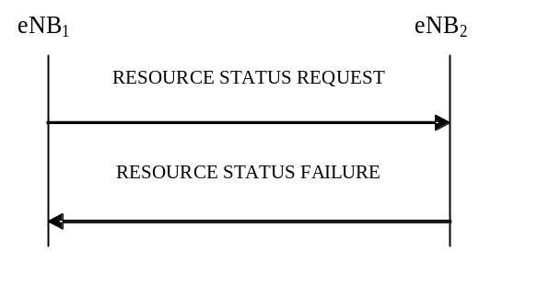
Figure 5 Resource Status Reporting Initiation, unsuccessful operation
If the requested measurement cannot be initiated, eNB2 shall send a RESOURCE STATUS FAILURE message. The Cause IE shall be set to an appropriate value e.g. "Measurement Temporarily not Available".
如果所请求的测量不能启动，eNB2应回复一条RESOURCE STATUS FAILURE消息，原因置为类似“Measurement Temporarily not Available”的值。
Table 11 RESOURCE STATUS FAILURE
IE/Group Name | Presence | IE type and reference | Criticality | Assigned Criticality
Message Type | M | 9.2.13 | YES | reject
eNB1 Measurement ID | M | INTEGER (1..4095,...) | YES | reject
eNB2 Measurement ID | M | INTEGER (1..4095,...) | YES | reject
Cause | M | 9.2.6 | YES | ignore
Criticality Diagnostics | O | 9.2.7 | YES | ignore
If the initiating eNB₁ does not receive either RESOURCE STATUS RESPONSE message or RESOURCE STATUS FAILURE message, the eNB₁ may reinitiate the Resource Status Reporting Initiation procedure towards the same eNB, provided that the content of the new RESOURCE STATUS REQUEST message is identical to the content of the previously unacknowledged RESOURCE STATUS REQUEST message.
如果eNB1既没有收到RSP也没有收到FAILURE消息，那么它应对同一个eNB重新启动Resource Status Reporting Initiation过程，再发送一条与之前未收到确认的内容相同的RESOURCE STATUS REQUEST消息。
Abnormal Conditions
If the Report Characteristics IE bitmap is set to "0" (all bits are set to "0") in the RESOURCE STATUS REQUEST message then eNB₂ shall initiate a RESOURCE STATUS FAILURE message, the cause shall be set to appropriate value e.g. "ReportCharacteristicsEmpty".
如果Report Characteristics所有的位都被置为0，eNB2应回复原因为“ReportCharacteristicsEmpty”的失败消息；
If the Reporting Periodicity IE value is not specified when at least one of the bits of the Report Characteristics IE, for which semantics is specified, is set to 1 then eNB₂ shall initiate a RESOURCE STATUS FAILURE message, the cause shall be set to appropriate value e.g. "NoReportPeriodicity".
如果当Report Characteristics的至少一位被置为1，但是Reporting Periodicity却没有被指明，回复原因为“NoReportPeriodicity”的失败消息；
If the eNB₂ received a RESOURCE STATUS REQUEST message which includes the Registration Request IE set to "start" and the eNB1Measurement ID IE corresponding to an existing on-going load measurement reporting, then eNB₂ shall initiate a RESOURCE STATUS FAILURE message, the cause shall be set to appropriate value e.g. "ExistingMeasurementID".
如果收到的消息中，Registration Request被置为“start”，但是eNB1Measurement ID相应的已经存在正在进行的负载测量报告了，则回复原因为“ExistingMeasurementID”的失败消息；
If the Registration Request IE is set to "stop" and the RESOURCE STATUS REQUEST message does not contain eNB2 Measurement ID IE, eNB₂ shall consider the procedure as failed and respond with the RESOURCE STATUS FAILURE message, the cause shall be set to appropriate value e.g. "Unknown eNB Measurement ID".
如果Registration Request被置为“stop”，但却未包含eNB2 Measurement ID，应回复原因为“Unknown eNB Measurement ID”的失败消息。
Table 12 Cause (RNL)
IE/Group Name | Presence | IE Type and Reference
CHOICE Cause Group | M
>Radio Network Layer
>>Radio Network Layer Cause | M | ENUMERATED  (  Handover Desirable for Radio Reasons,  Time Critical Handover,  Resource Optimisation Handover,  Reduce Load in Serving Cell,  Partial Handover,  Unknown New eNB UE X2AP ID,  Unknown Old eNB UE X2AP ID,  Unknown Pair of UE X2AP ID,  HO Target not Allowed,  TX2_{RELOCoverall} Expiry,  T_{RELOCprep} Expiry,  Cell not Available,  No Radio Resources Available in Target Cell,  Invalid MME Group ID,  Unknown MME Code,  Encryption And/Or Integrity Protection Algorithms Not Supported,  ReportCharacteristicsEmpty,  NoReportPeriodicity,  ExistingMeasurementID,  Unknown eNB Measurement ID,  Measurement Temporarily not Available,  Unspecified,  ...,  Load Balancing,  Handover Optimisation,  Value out of allowed range,  Multiple E-RAB ID instances,  Switch Off Ongoing,  Not supported QCI value  )

3.2.3 Cell Activation
The purpose of the Cell Activation procedure is to request to a neighbouring eNB to switch on one or more cells, previously reported as inactive due to energy saving reasons.
小区激活过程的目的是请求临eNB把之前因节能而报告为未激活的一个或多个小区开启。
The procedure uses non UE-associated signalling.
与UE无关的信令过程。
Successful Operation
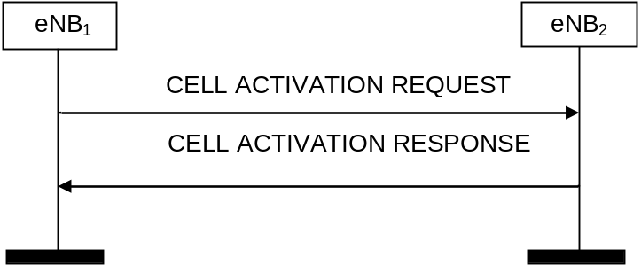
Figure 6 Cell Activation, successful operation
An eNB1 initiates the procedure by sending a CELL ACTIVATION REQUEST message to a peer eNB2.
eNB1通过发送CELL ACTIVATION REQUEST消息给eNB2来启动该过程。
Upon receipt of this message, eNB2 should activate the cell/s indicated in the CELL ACTIVATION REQUEST message and shall indicate in the CELL ACTIVATION RESPONSE message for which cell the request was fulfilled.
一旦收到该消息，eNB2应该激活消息中指示的小区，并在执行了请求后回复CELL ACTIVATION RESPONSE消息。
Table 13 CELL ACTIVATION REQUEST
IE/Group Name | Presence | Range | IE type and reference | Semantics description | Criticality | Assigned Criticality
Message Type | M |  | 9.2.13 |  | YES | reject
Served Cells To Activate |  | 1 to maxCellineNB |  |  | GLOBAL | reject
>ECGI | M |  | 9.2.14 |  | - | -
Table 14 ECGI
IE/Group Name | Presence | Range | IE type and reference | Semantics description | Criticality | Assigned Criticality
PLMN Identity | M |  | 9.2.4 |  | – | –
E-UTRAN Cell Identifier | M |  | BIT STRING (28) | The leftmost bits of the E-UTRAN Cell Identifier IE value correspond to the value of the eNB ID IE contained in the Global eNB ID IE (defined in section 9.2.22) identifying the eNB that controls the cell | – | –
Table 15 CELL ACTIVATION RESPONSE
IE/Group Name | Presence | Range | IE type and reference | Semantics description | Criticality | Assigned Criticality
Message Type | M |  | 9.2.13 |  | YES | reject
Activated Cell List |  | 1 to maxCellineNB |  |  | GLOBAL | ignore
>ECGI | M |  | 9.2.14 |  | - | -
Criticality Diagnostics | O |  | 9.2.7 |  | YES | ignore
Interactions with eNB Configuration Update procedure:
与eNB Configuration Update过程的交互：
eNB2 shall not send an ENB CONFIGURATION UPDATE message to eNB1 just for the reason of the cell/s indicated in the CELL ACTIVATION REQUEST message changing state, as the receipt of the CELL ACTIVATION RESPONSE message by eNB1 is used to update the information about cell activation state of eNB2 cells in eNB1.
如果只是CELL ACTIVATION REQUEST消息中所指示的小区而改变状态，那么eNB2不应该给eNB1发送ENB CONFIGURATION UPDATE消息，因为eNB1收到的CELL ACTIVATION RESPONSE消息是用来在eNB1中更新eNB2小区激活状态信息的。
Unsuccessful Operation
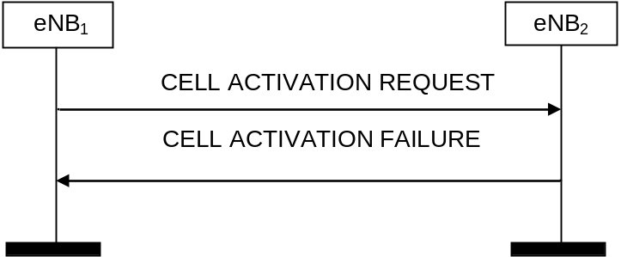
Figure 7 Cell Activation, unsuccessful operation
If the eNB₂ cannot activate any of the cells indicated in the CELL ACTIVATION REQUEST message, it shall respond with a CELL ACTIVATION FAILURE message with an appropriate cause value.
如果eNB2无法激活任何CELL ACTIVATION REQUEST消息中指示的小区，那么它应该回复带有相应原因的CELL ACTIVATION FAILURE消息
Table 16 CELL ACTIVATION FAILURE
IE/Group Name | Presence | Range | IE type and reference | Semantics description | Criticality | Assigned Criticality
Message Type | M |  | 9.2.13 |  | YES | reject
Cause | M |  | 9.2.6 |  | YES | ignore
Criticality Diagnostics | O |  | 9.2.7 |  | YES | ignore

